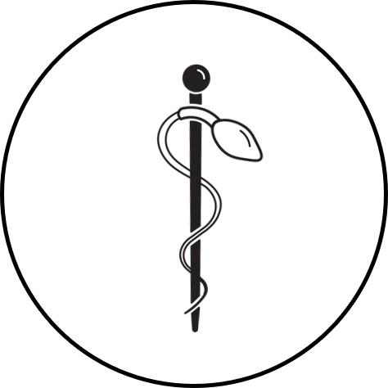
Vasectomy Central
Privacy policy

All information is collected in compliance with section 33 (c) of the Freedom of Information and Protection of Privacy (FOIP) Act.
When you visit this site, our web server automatically collects a limited amount of standard information essential to the operation and evaluation of the site. This information is not used to identify individuals who come to the site, nor is it disclosed to other public bodies or individuals.
The information that's collected identifies the following:
- the page from which you arrived
- the date and time of your page request
- the IP address your computer is using to receive information
- the type and version of your browser
- the name and size of the file you request

Personal information
The only information we may use to identify you is the information you give voluntarily..
This personal information is disclosed only to the authorized personnel who use it to process and respond to your request.

Cookies
When you visit a website it may deposit a piece of data, called a web cookie, with the temporary web browser files on your computer.
If you wish, you can change the settings on your web browser to deny cookies, or to warn you when a site is about to deposit cookies on your hard drive.
Vasectomy Central uses cookies to collect anonymous statistical information such as browser type, screen size, traffic patterns and pages visited. This information helps us provide you with better service. We do not store personal information in cookies, nor do we collect personal information from you without your knowledge, as you browse the site.

Cookies from third party applications
This site uses a number of third party products. Read their privacy statements to find out how they track and use your information:
- Facebook cookie policy
- Google Analytics privacy statement
- Google Ads cookie usage

